

**Lao People’s Democratic Republic**

**Peace Independence Democracy Unity Prosperity**

**REQUEST FOR QUOTATION FOR THE PROCUREMENT OF GOODS OR NON-CONSULTING SERVICES**

**​ HARMONIZED VERSION**

**For the World Bank-financed projects only**

**​ Vientiane Capital, July 2021**

**Foreword**

This Request for Quotations for Goods or Non-Consulting Services has been revised based on the Harmonized Request for Quotations for Goods or Non-Consulting Services, July 2021. It has been prepared by the Procurement Team based in the Vientiane World Bank Office intending to be used under the World Bank-financed projects only.



**Lao People's Democratic Republic**

**Peace Independence Democracy Unity Prosperity**

Ministry of Industry and Commerce

Permanent Secretary Office

National Implementation Unit (NIU)

Lao PDR Competitiveness and Trade Project

Contract No. RFQ/018/LCTP

No.

Date: 12 August 2024

**Request for Quotation**

**Simultaneous Interpretation Equipment**

To: Eligible Suppliers

1. The Government of Lao PDR has received financing in the amount of 19.50 Million USD which consists of 10 Million USD from the World Bank’s International Development Association (IDA) and 9.50 Million USD from the Multi-Donor Trust Fund (MDTF), Australia, Ireland, USAID for the cost of Lao PDR Competitiveness and Trade Project and intends to apply part of the proceeds of these funds towards payments under the Contract for Procurement of Rack Server under this Request for Quotation.
2. The NIU now invites eligible Companies to submit the sealed Quotation for the **Simultaneous Interpretation Equipment** as specified in section 5 Schedule of Items and Prices. The delivery period is: **Sixty (60) Calendar days** after the date of signature, including assembly, installation, and setup service.
3. Bidding will be conducted through the Request for Quotation procedure specified in the Law on Public Procurement Law No30/NA**,** dated2Nov2017and the Instruction of Implementation of Law on Public Procurement**,** No. **0477**/MOF**,** dated13Feb2019**.**
4. A complete set of the Bid Documents is available on <http://www.t4dlaos.org/procurement-notices/> for free for the interested bidders to register and upload the application (Request letter with official stamp) online beginning **12 August 2024.** The Bid Documents will be sent via email after the online registration is completed.
5. The Quotation shall be delivered before **14:00’clock, 26 August 2024** **to National Implementation Unit (NIU), 3rd floor, Permanent Secretary Office, Ministry of Industry and Commerce, Phonexay Road, Saysettha District, Vientiane Capital, Lao PDR. Tel: 021 413916**, and all Quotations will be opened at **14:05’clock, 26 August 2024** in the presence of the Tender Committee and the Bidder’s representatives who choose to attend.

**Lattanaphone Vongsouthi**

**NIU Director**

**LCT Project Manager**

**Section 1: Instruction to the Bidders [ITB]**

1. **Description of Goods:** The NIU invites quotations for the Goods of Office Furniture*.* The successful Bidder is expected to deliver the goods or Non-Consulting service within the time specified under Section 3: Condition of the Contract paragraph 6.
2. **Eligible Bidders:**

The Bidder shall provide information specified in Section 2: Bidder Information Sheet (items 1-5).

1. **Fraud and Corruption:**
2. **the World Bank defines, for the purposes of this provision, the terms set forth below as follows:**
3. **Purpose**
   1. The Bank’s Anti-Corruption Guidelines and this annex apply with respect to procurement under Bank Investment Project Financing operations.
4. **Requirements**
5. The Bank requires that Borrowers (including beneficiaries of Bank financing); bidders (applicants/proposers), consultants, contractors and suppliers; any sub-contractors, sub-consultants, service providers or suppliers; any agents (whether declared or not); and any of their personnel, observe the highest standard of ethics during the procurement process, selection and contract execution of Bank-financed contracts, and refrain from Fraud and Corruption.
6. To this end, the Bank:
7. Defines, for the purposes of this provision, the terms set forth below as follows:
8. “corrupt practice” is the offering, giving, receiving, or soliciting, directly or indirectly, of anything of value to influence improperly the actions of another party;
9. “fraudulent practice” is any act or omission, including misrepresentation, that knowingly or recklessly misleads, or attempts to mislead, a party to obtain financial or other benefit or to avoid an obligation;
10. “collusive practice” is an arrangement between two or more parties designed to achieve an improper purpose, including to influence improperly the actions of another party;
11. “coercive practice” is impairing or harming, or threatening to impair or harm, directly or indirectly, any party or the property of the party to influence improperly the actions of a party;
12. “obstructive practice” is:
13. deliberately destroying, falsifying, altering, or concealing of evidence material to the investigation or making false statements to investigators in order to materially impede a Bank investigation into allegations of a corrupt, fraudulent, coercive, or collusive practice; and/or threatening, harassing, or intimidating any party to prevent it from disclosing its knowledge of matters relevant to the investigation or from pursuing the investigation; or
14. acts intended to materially impede the exercise of the Bank’s inspection and audit rights provided for under paragraph 2.2 e. below.
15. Rejects a proposal for award if the Bank determines that the firm or individual recommended for award, any of its personnel, or its agents, or its sub-consultants, sub-contractors, service providers, suppliers and/ or their employees, has, directly or indirectly, engaged in corrupt, fraudulent, collusive, coercive, or obstructive practices in competing for the contract in question;
16. In addition to the legal remedies set out in the relevant Legal Agreement, may take other appropriate actions, including declaring misprocurement, if the Bank determines at any time that representatives of the Borrower or of a recipient of any part of the proceeds of the loan engaged in corrupt, fraudulent, collusive, coercive, or obstructive practices during the procurement process, selection and/or execution of the contract in question, without the Borrower having taken timely and appropriate action satisfactory to the Bank to address such practices when they occur, including by failing to inform the Bank in a timely manner at the time they knew of the practices;
17. Pursuant to the Banks Anti-Corruption Guidelines and in accordance with the Bank’s prevailing sanctions policies and procedures, may sanction a firm or individual, either indefinitely or for a stated period of time, including by publicly declaring such firm or individual ineligible (i) to be awarded or otherwise benefit from a Bank-financed contract, financially or in any other manner;[1] (ii) to be a nominated[2] sub-contractor, consultant, manufacturer or supplier, or service provider of an otherwise eligible firm being awarded a Bank-financed contract; and (iii) to receive the proceeds of any loan made by the Bank or otherwise to participate further in the preparation or implementation of any Bank-financed project;
18. Requires that a clause be included in bidding/request for proposals documents and in contracts financed by a Bank loan, requiring (i) bidders (applicants/proposers), consultants, contractors, and suppliers: and their sub-contractors, sub-consultants, service providers, suppliers, agents, personnel, permit the Bank to inspect[3] all accounts, records and other documents relating to the procurement process, selection and/or contract execution, and to have them audited by auditors appointed by the Bank.
19. **Content of the request for quotations:**

Section 1: Instruction to Bidders

Section 2: Bidder Information Sheet

Section 3: Conditions of contract

Section 4: Quotation Submission Form

Section 5: Schedule of Items and Prices

Section 6: Technical Specification

Section 7: List of Goods and Delivery Schedule

Section 8: Drawing/Brochure

Section 9: Contract Forms

1. Form 1: Notification of Intention to Award
2. Form 2:  Notification of Award
3. Form 3: Contract Agreement
4. Remark: In case of Procuring Entity Considers the Manufacturer Authorization is needed, it is recommended to use the Manufacturer Authorization form from the Open Standard Bidding document for Procurement of goods.
5. **Documents comprising the Quotation:** Quotation submitted by the Bidders shall comprise the following documents:
   1. Quotation Form with an original letter naming the person authorised to sign on behalf of the Bidder.
   2. Schedule of Items and Prices
   3. Technical Specification of the Goods to be supplied
   4. Bidder Information Sheet
   5. List of Goods and Delivery Schedule
   6. The appropriate original printed literature / brochures for the various items listed.
6. **Quotation and Evaluation criteria:** The Bidder’s quotation shall be for all items required and specified in Section 5: Schedule of Items and Prices. The Procuring Entity has the right to reject quotations that:
7. Do not respond to all the items specified in the Schedule of Items.
8. The proposed technical specifications do not meet the requirements in a substantial way.

The Procuring Entity will award the contract to the Bidder whose quotation has been determined to be substantially responsive to the Request for Quotation and who has offered the lowest evaluated quotation.

1. **Validity of Quotation:** The Quotation shall remain valid for the period of **Sixty (60) calendar days** after the deadline for submission of quotations specified in ITB 14
2. **Submission of Quotation:** Each Bidder shall submit only one Quotation
3. **Currency of Quotation:** All prices shall be quoted in Lao Kip. The bidders may price in USD to be paid in Lao KIP currency at the prevailing exchange rate at the time of payment.
4. **Bid Price:** The quoted price shall include taxes including profit tax, duty, inland transportation, insurance and costs incidental to delivery of the goods to their final destination. The quoted price shall be fixed for the duration of contract.
5. **Warranty:** Warranty at least One (1) year after the Final Acceptance Date.
6. **After sale Services:** The Supplier should also provide free of labour charges for checking and inspection/installation of goods, and for Related Services.
7. **Preparation and Sealing of Quotation:** The Bidder shall prepare one original of the documents comprising the quotation as described in ITB 4 and marked “Original”. In addition, the Bidder shall also submit 02 copies and marked “Copy”. In the event of any discrepancy between the original and the copies, the original shall prevail. The original and each copy of the Quotation shall be typed or written in indelible ink and shall be signed by a person duly authorised to sign on behalf of the Bidder. The name and position held by each person signing the authorisation must be typed or printed below the signature. Any interlineations, erasures, or overwriting shall be valid only if they are signed or initialled by the person(s) signing the Quotation.
8. **Place and deadline of submission of Quotation:** The Quotation shall be delivered no later than **14:00’clock, 26 August 2024** to **National Implementation Unit (NIU), 3rd floor, Permanent Secretary Office, Ministry of Industry and Commerce, Phonexay Road, Saysettha District, Vientiane Capital, Lao PDR. Tel: 021 413916.** Any Quotation received after the deadline prescribed in this paragraph will be rejected and returned unopened to the Bidder.
9. **Modification and withdrawal of Quotations:** The Bidder may withdraw its Quotation after submission, provided that written notice of the withdrawal is received by the Procuring Entity prior to the deadline for submission. No Quotations shall be modified after the deadline for submission of Quotations specified above in ITB 14. Withdrawal of a quotation between the deadline for submission of quotation and expiration of the validity may result in ineligibility of the Bidder.
10. **Opening of Quotations** will be held on **26 August 2024, 14:05’clock** and place as specified in the request for Quotation in the presence of the Tender Committee and the Bidders’ representatives who choose to attend. The Bidders names, modifications or withdrawals, quotation prices, discounts will be announced at the opening. The Procuring Entity shall provide to all attendees written minutes of the bid opening. No bid shall be rejected at the bid opening, except for late quotations.
11. **Immediately after completion of the opening proceedings**, a copy of the opening record shall be posted at a prominent location, accessible to the public, outside the office of the Procuring Entity and shall be retained at the same location until the contract award has been notified. A copy of the bid opening record shall be provided to all Bidders who submitted quotations.
12. **Confidential:** After the opening of Quotations, information relating to the examination, clarification, and evaluation of Quotations and recommendations for award shall not be disclosed to Bidders or other persons not officially concerned with the evaluation process until after the award of the Contract is announced.
13. **Evaluation and Comparison of Quotation:** The Procuring Entity will award the contract to the Bidder whose quotation has been determined to be substantially responsive to the Request for Quotation and who has offered the lowest evaluated quotation. In evaluating the quotations, the tender committee will determine for each quotation the evaluated price by adjusting the quotation by marking any correction for any arithmetic errors as follows:
    1. Where there is a discrepancy between amount in figures and in words, the amount in word will govern,
    2. Where there is a discrepancy between the unit rate and the line-item total resulting from multiplying the unit rate by the quantity, the unit rate as quoted will govern, unless in the opinion of the Procuring Entity there is an obvious misplacement of the decimal point in the unit price, in which case the line-item total as quoted shall govern and the unit price shall be corrected.
14. **The Procuring Entity’s right:** Depending on the final requirement, the Procuring Entity may increase or decrease the quantity or items list by up to 15%. If any such change causes an increase or decrease in the quantity or items list, the rationale for the change shall be specified in the bid evaluation report for the procurement. The Procuring Entity reserves the right to accept or reject any quotations, and to cancel the process of the competition and reject all quotations, at any time prior to the award of the contract, without thereby incurring any liability to affected Bidders or any obligation to inform the affected Bidders of grounds.
15. **Notification of Intention to Award:**

Prior to the expiration of the period of validity of the quotation, the Procuring Entity shall send to each Bidder the Notification of Intention to Award the Contract to the successful Bidder by using the relevant form for Notification of Intention to Award FORM1-Section 9: Contract forms.

1. **Complaints:** Any Bidder has the right to complain, if it has suffered or may suffer loss or damage due to a breach of a duty imposed by the Procuring Entity based on the Law on Public Procurement No. 30/NA, date 2 November 2017 and Instruction of Implementation of Law on Public Procurement, Ministry of Finance No. 0477/MOF, 13 February 2019. The Complaint shall be submitted to the Procuring Entity and Public Procurement Division (PPD) of Ministry of Finance.
2. **Debriefing by the Procuring Entity:** On receipt of the Procuring Entity’s Notification of Intention to Award, an unsuccessful Bidder has three (3) Business Days to make a written request to the Procuring Entity for a debriefing. The Procuring Entity shall provide a debriefing to all unsuccessful Bidders whose request is received within this deadline. Where a request for debriefing is received within the deadline, the Procuring Entity shall provide a debriefing within five (5) Business Days, unless the Procuring Entity decides, for justifiable reasons, to provide the debriefing outside this timeframe. In that case, the standstill period shall automatically be extended until five (5) Business Days after such debriefing is provided. If more than one debriefing is so delayed, the standstill period shall not end earlier than five (5) Business Days after the last debriefing takes place. The Procuring Entity shall promptly inform, by the quickest means available, all Bidders of the extended standstill period. Where a request for debriefing is received by the Procuring Entity later than the three (3)-Business Day deadline, the Procuring Entity should provide the debriefing as soon as practicable, and normally no later than fifteen (15) Business Days from the date of publication of Public Notice of Award of contract. Requests for debriefing received outside the three (3)-day deadline shall not lead to extension of the standstill period. Debriefings of unsuccessful Bidders may be done in writing. The Bidders shall bear their own costs of attending such a debriefing meeting. The complaint should be copied to the relevant financial institutions (WB).
3. **Signing of Contract:** Prior to the expiration of the Bid Validity Period and upon expiry of the Standstill Period, or any extension thereof, and upon satisfactorily addressing any complaint that has been filed within the Standstill Period, the Procuring Entity shall send to the successful Bidder the Notification of Award in Section 8 including the Contract Agreement. The successful Bidder shall sign, date and return to the Procuring Entity, the Contract Agreement within fourteen (14) days of its receipt.
4. **The signed Contract Agreement** shall be registered by the Supplier, in accordance with the Instruction on Implementation of Law on Public Procurement.
5. **Publication of Contract Award:** Within fourteen (14) Business Days after the date of transmission of the Notification of Intention to Award, the Procuring Entity shall publish the Contract Award Notice on relevant ministry public website or Facebook page or Local newspaper as well as in a prominent location, accessible to the public, outside the office of the Procuring Entity, (a) name of each Bidder who submitted a bid; (b) prices as read out at quotation opening; (c) name and evaluated price of each quotation that was evaluated; (d) name of Bidders whose quotations were rejected and the reasons for rejection; (e) name of the winning Bidder, contract price, explanation if it is different from the quoted price, as well as the duration and summary scope of the contract awarded.

**Section 2:** **Bidder Information Sheet**

The Bidder is required to furnish:

1. Bidder’s Legal Name, Address,
2. Copy of Business Licenses
3. Business Operating License, or Business Licence Extension Certification
4. Tax payment Certificate 2022/2023 or Tax payment Extension and
5. Original letter naming the person authorised to sign on behalf of the Bidder, if any.

**Section 3: Conditions of Contract**

1. **The following documents forming the contract** shall be interpreted in the following order of priority:
   1. The signed Contract Agreement
   2. The conditions of contract
   3. Schedule of Items and Prices
   4. Technical Specification of the Goods
   5. List of Goods and Delivery Schedule
   6. The appropriate original printed literature / brochures for the various items listed.
2. **This Contract shall be amended only** by written agreement between the Procuring Entity and the Supplier or Service provider.
3. **Fraud and Corruption:**

the World Bank defines Fraud and Corruption, for the purposes of this provision, as the terms set forth below as follows:

1. **Purpose**

The Bank’s Anti-Corruption Guidelines and this annex apply with respect to procurement under Bank Investment Project Financing operations.

1. **Requirements**
2. The Bank requires that Borrowers (including beneficiaries of Bank financing); bidders (applicants/proposers), consultants, contractors and suppliers; any sub-contractors, sub-consultants, service providers or suppliers; any agents (whether declared or not); and any of their personnel, observe the highest standard of ethics during the procurement process, selection and contract execution of Bank-financed contracts, and refrain from Fraud and Corruption.
3. To this end, the Bank:
4. Defines, for the purposes of this provision, the terms set forth below as follows:
5. “corrupt practice” is the offering, giving, receiving, or soliciting, directly or indirectly, of anything of value to influence improperly the actions of another party;
6. “fraudulent practice” is any act or omission, including misrepresentation, that knowingly or recklessly misleads, or attempts to mislead, a party to obtain financial or other benefit or to avoid an obligation;
7. “collusive practice” is an arrangement between two or more parties designed to achieve an improper purpose, including to influence improperly the actions of another party;
8. “coercive practice” is impairing or harming, or threatening to impair or harm, directly or indirectly, any party or the property of the party to influence improperly the actions of a party;
9. “obstructive practice” is:
10. deliberately destroying, falsifying, altering, or concealing of evidence material to the investigation or making false statements to investigators in order to materially impede a Bank investigation into allegations of a corrupt, fraudulent, coercive, or collusive practice; and/or threatening, harassing, or intimidating any party to prevent it from disclosing its knowledge of matters relevant to the investigation or from pursuing the investigation; or
11. acts intended to materially impede the exercise of the Bank’s inspection and audit rights provided for under paragraph 3.2.2 e. below.
12. Rejects a proposal for award if the Bank determines that the firm or individual recommended for award, any of its personnel, or its agents, or its sub-consultants, sub-contractors, service providers, suppliers and/ or their employees, has, directly or indirectly, engaged in corrupt, fraudulent, collusive, coercive, or obstructive practices in competing for the contract in question;
13. In addition to the legal remedies set out in the relevant Legal Agreement, may take other appropriate actions, including declaring misprocurement, if the Bank determines at any time that representatives of the Borrower or of a recipient of any part of the proceeds of the loan engaged in corrupt, fraudulent, collusive, coercive, or obstructive practices during the procurement process, selection and/or execution of the contract in question, without the Borrower having taken timely and appropriate action satisfactory to the Bank to address such practices when they occur, including by failing to inform the Bank in a timely manner at the time they knew of the practices;
14. Pursuant to the Banks Anti-Corruption Guidelines and in accordance with the Bank’s prevailing sanctions policies and procedures, may sanction a firm or individual, either indefinitely or for a stated period of time, including by publicly declaring such firm or individual ineligible (i) to be awarded or otherwise benefit from a Bank-financed contract, financially or in any other manner;[4] (ii) to be a nominated[5] sub-contractor, consultant, manufacturer or supplier, or service provider of an otherwise eligible firm being awarded a Bank-financed contract; and (iii) to receive the proceeds of any loan made by the Bank or otherwise to participate further in the preparation or implementation of any Bank-financed project;
15. Requires that a clause be included in bidding/request for proposals documents and in contracts financed by a Bank loan, requiring (i) bidders (applicants/proposers), consultants, contractors, and suppliers: and their sub-contractors, sub-consultants, service providers, suppliers, agents, personnel, permit the Bank to inspect[6] all accounts, records and other documents relating to the procurement process, selection and/or contract execution, and to have them audited by auditors appointed by the Bank.
16. **Price adjustment and variation:** Price adjustment and variation are not applicable to this contract.
17. **Payment****:** The payment for the Supplier shall be made in Lao Kip by transfer to bank account of Supplier within 30 daysof delivery of goods to the final destination and acceptance as specified in Clause 8 (packaging of goods) and clause 9 (Inspection). 100% of the contract price shall be paid against submission of the Certificate of Acceptance and invoice *[one original and number of copies*]. The payment method shall be made as specified in the Supplier’s invoice. Payment of VAT/Taxes and other impositions shown in the Supplier’s invoice shall be made in accordance with the current regulations, at the time of settlement of the invoice.
18. **Delivery time:** All goods shall be delivered to the Procuring Entity within **Sixty (60) days** from date of contract signed.
19. **Late delivery:** If the Supplier delivers the specified goods later than the delivery period specified in clause 6, the Procuring Entity has the right to reduce the payment to the supplier by **1%**of the total price of contract for each day of delay beyond the delivery time. The deduction is up to a maximum of the 10%, and then the Procuring Entity may terminate the contract.
20. **Packaging of goods:** The Supplier shall warrant those goods are contained or packaged adequately to protect the goods from loss or damage when transporting to the final destination of delivery.
21. **Inspection:** Within 3 days of delivery, the Procuring Entity shall inspect the goods delivered to ensure compliance with the requirement of contract. If no fault is found, a certificate of acceptance should be issued to the Supplier.
22. **Intellectual Property infringement:** The Supplier warrants the use by the Procuring Entity of the goods sold under this contract does not infringe any patent, design, trade name or trademark. In addition, the supplier shall, pursuant to this warranty, indemnify, defend and hold the Procuring Entity harmless from any action or claim pertaining to the alleged infringement of patent, design, trade name or trade mark arising in connection with the goods sold under this contract.
23. **Warranty:** The Supplier shall provide the warranty of at least **One (01) year** after final acceptance. And if any faults are detected within the warranty period in the supplied/installed goods, the Supplier shall be bound to rectify the fault or replace the goods within 14 days.
24. **Termination of Contract:** The Procuring Entity may, by written notice sent to the Supplier, terminate the Contract in whole or in part at any time for its convenience:
    * 1. if the Supplier or Service provider fails to deliver any or all the goods or service within the time period(s) specified in this contract, or
      2. if the Supplier or Service provider fails to perform any other obligation(s) under this contract, or
      3. if the Supplier or Service provider, in either of the above circumstances does not cure its failure within a period of (3) three calendar days after receipt of a notice of default from the Procuring Entity specifying the nature of the default(s), or
      4. if the Supplier or Service provider, in the judgment of the Procuring Entity, has engaged in any corrupt or fraudulent practices in competing for or in executing the tasks under this contract.
25. **Settlement of disputes:** During contract implementation, if any dispute arises between the two parties, relating to any aspects of this Agreement, the parties shall first attempt to settle the dispute through mutual and amicable consultation. In the event of agreement not being reached, the complaint shall be submitted to the Procuring Entity and Public Procurement Division (PPD) of Ministry of Finance. Such complaint should also be copied to the concerned financial institution.

Section 4: Quotation Form

Insert Logo of the Company

|  |  |
| --- | --- |
| Insert Address:  Request for Quotation No: | Date: |
| To:  *[Insert Name and address of the Procuring Entity]* |  |

Having examined the Request for Quotations, the receipt of which is here by duly acknowledged. We, the undersigned, offer to supply ***Simultaneous Interpretation Equipment*** in conformity with the said Request for Quotation in total Price:

* In case of only one lot, total price of the Bid **[*insert the total price of the bid in words and figures in Kip/USD*];**
* In case of multiple lots, total price of each lot **[*insert the total price of each lot in words and figures in Kip/USD]*;**
* In case of multiple lots, total price of all lots (sum of all lots) **[*insert the total price of all lots in words and figures*]**.

We undertake, if our Quotation is accepted, to deliver the goods or service **Sixty (60) days** from the date of the signed contract, in accordance with the delivery time specified in clause 6 of the Conditions of Contract.

We are not participating as Bidders in more than one Quotation in this price comparison process. Our Quotation shall be valid for **Thirty (60) *days*** after the deadline for submission of Quotations.

We declare that ourselves and any Suppliers for any part of the Contract have not been declared ineligible by the Government and/or World Bank/ADB on charges of engagement in corrupt, fraudulent, collusive, coercive or obstructive practices. We, furthermore, pledge not to indulge such practices in the duration of the Contract.

We understand that your written Notification of Award shall constitute the acceptance of our Quotation and shall become a binding contract between us, until a formal contract is prepared and executed.

We understand that you are not bound to accept the lowest or any Quotation that you may receive.

**Signature and Stamp of Supplier**

Name of Supplier

**Section 5: Schedule of Items and Prices**

|  |  |  |  |  |  |
| --- | --- | --- | --- | --- | --- |
| **Item** | **Name of goods or Non-Consulting service and Description** | **Unit** | **Quantity**  **(1)** | **Unit Rate (Kip/USD) DDP**[7]  **(2)** | **Total Amount**  **(Kip/USD)**  **(3) = (1) x (2)** |
| (a) | (b) | (c) | (d) | (e) | (f) |
| 1 | Transmitter | Unit | 2 |  |  |
| 2 | Receiver | Unit | 20 |  |  |
| 3 | Lavalier microphone for transmitter | Unit | 2 |  |  |
| 4 | Single ear headphone for receiver | Unit | 20 |  |  |
| 5 | Headset microphone for transmitter | Unit | 1 |  |  |
| 6 | Charging case for transmitters and receivers | Unit | 1 |  |  |
| I | Total Cost | | | |  |
| II | VAT 10% (Included total cost) | | | |  |
| III | Contract Registration Fee[8] | | | |  |
|  | Grand Total (*write in number)* | | | |  |
|  | Grand Total (*write in word*) | | | |  |

|  |  |
| --- | --- |
| Delivery Offered | *[Insert number of days/weeks/Months]* |
| Warranty Provided | *[(Insert number of days/weeks/Months]* |

**NOTE:** Note If the bidder dose not enter the value of item II, III, it is considered that those cost are included in the total of the contract price including the profit tax which shall be under responsibility of bidder.

Date:

Signature of Supplier and Stamp

Insert Name of Supplier or Service provider

**The attachment: Ordinance of the President No.002 on the Fees and Service Charges**

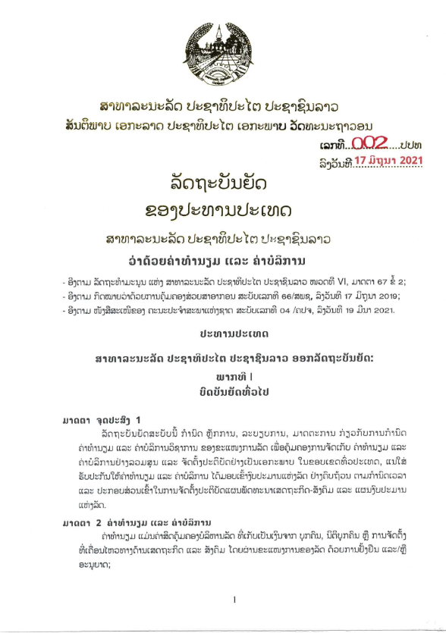

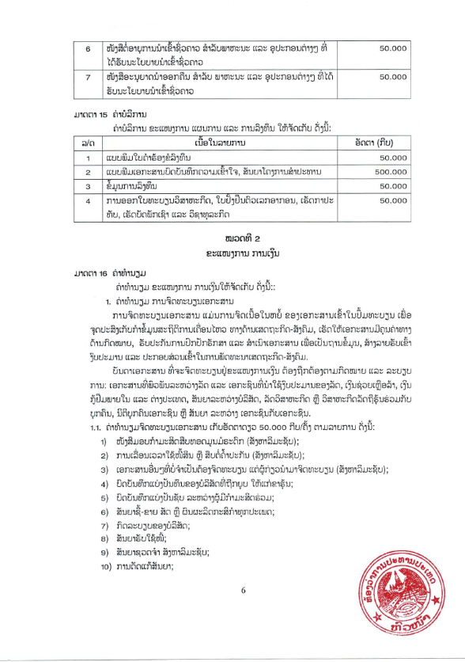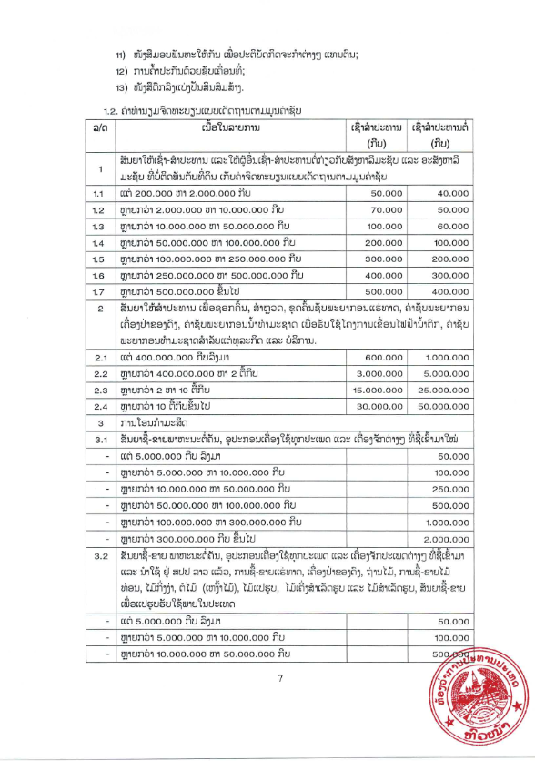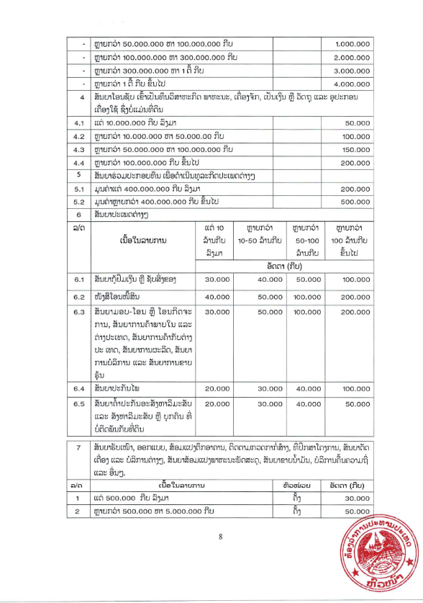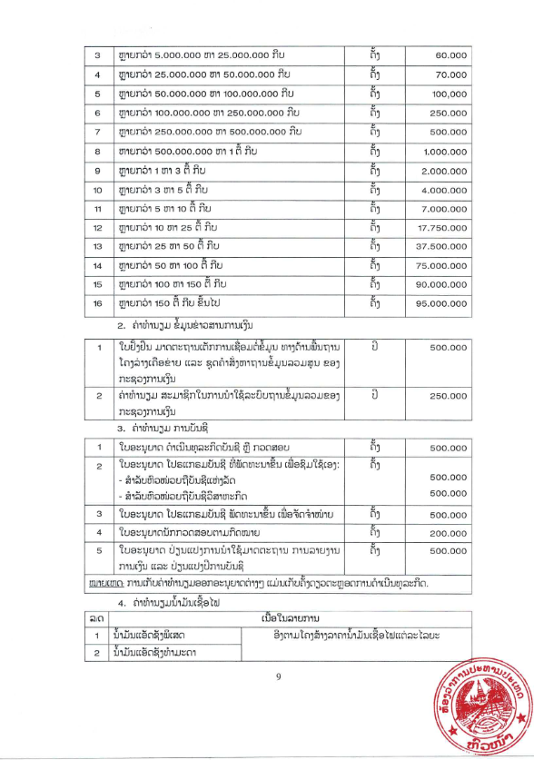

**Section 6: Technical Specification of the Goods Required**

|  |  |  |  |
| --- | --- | --- | --- |
| **Item** | **Name of goods and Technical Specification of Goods Required** | **Yes** | **Technical Specification of Goods to be offered** |
| **1** | **Transmitter** |  | **Brand:** |
| **Model:** |
|  | Form factor: Portable wireless tour guide transmitter |  |  |
|  | Operating frequency: 2.4 GHz signal |  |  |
|  | Channels: ≥ 999 |  |  |
|  | Transmitting distance: ≥ 150m range |  |  |
|  | Sound output quality: up to 16K or equivalent high-quality sound output |  |  |
|  | Battery run time: ≥ 18 hours |  |  |
|  | Noise reduction |  |  |
|  | Built-in microphone equipped |  |  |
|  | LED display: Showing the status of power, channel, and signal. |  |  |
|  | One-touch mute |  |  |
|  | AUX and MIC inputs |  |  |
|  | Weight: ≤ 100g |  |  |
|  | **Accessories:** Charging cable and lanyard included |  |  |
|  | **Warranty:** ≥1 year from final acceptance date |  |  |
|  | **Related Services:** See description below this table. |  |  |
| **2** | **Receiver** |  | **Brand:** |
| **Model:** |
|  | Form factor: Portable wireless tour guide receiver |  |  |
|  | Operating frequency: 2.4 GHz signal |  |  |
|  | Channels: ≥ 999 |  |  |
|  | Receiving distance: ≥ 150m range |  |  |
|  | Battery run time: ≥ 80 hours |  |  |
|  | LED display: Showing the status of power, channel, and signal. |  |  |
|  | Volume and channel adjustment buttons |  |  |
|  | Port: AUX |  |  |
|  | Weight: ≤ 100g |  |  |
|  | **Accessories:** Charging cable and lanyard included |  |  |
|  | **Warranty**: ≥1 year from final acceptance date |  |  |
|  | **Related Services:** See description below this table. |  |  |
| **3** | **Lavalier microphone for transmitter** |  | **Brand:** |
| **Model:** |
|  | Form factor: Clip-on lavalier microphone |  |  |
|  | Connectivity: cable compatible with Item #1 Transmitter |  |  |
|  | Sensitivity: -38dB ± 10% |  |  |
|  | Frequency response: 50Hz-16KHz |  |  |
|  | **Accessories:** Clip for easy attachment |  |  |
|  | **Warranty**: ≥1 year from final acceptance date |  |  |
|  | **Related Services:** See description below this table. |  |  |
| **4** | **Single ear headphone for receiver** |  | **Brand:** |
| **Model:** |
|  | Form factor: Single-ear D-shaped headphone compatible with both left and right ears |  |  |
|  | Connectivity: cable compatible with Item #2 Receiver |  |  |
|  | Frequency Response: 20Hz-20kHz |  |  |
|  | **Warranty**: ≥1 year from final acceptance date |  |  |
|  | **Related Services:** See description below this table. |  |  |
| **5** | **Headset microphone for transmitter** |  | **Brand:** |
| **Model:** |
|  | Form factor: standard wired headset microphone for transmitter |  |  |
|  | Connectivity: cable compatible with Item #1 Transmitter |  |  |
|  | Frequency Response: 20Hz-20kHz |  |  |
|  | Sensitivity: -48dB ± 10% |  |  |
|  | **Warranty**: ≥1 year from final acceptance date |  |  |
|  | **Related Services:** See description below this table. |  |  |
| **6** | **Charging case for transmitter and receiver** |  | **Brand:** |
| **Model:** |
|  | Form factor: Portable charging case with multiple slots for storage and charging of transmitters and receivers |  |  |
|  | Material: Durable and drop-proof shell |  |  |
|  | Charging Time: Full charge for all devices simultaneously within 4-6 hours |  |  |
|  | Charging capacity: ≥ 20 charging slots for transmitters/receivers simultaneously |  |  |
|  | Charing type: Single-cable plug-in for simultaneous charging |  |  |
|  | Power supply: AC 220-240V, 50/60Hz |  |  |
|  | **Compatibility:** Fully compatible with the specified Item#1 Transmitter and Item #2 Receiver |  |  |
|  | **Warranty**: ≥1 year from final acceptance date |  |  |
|  | **Related Services:** See description below this table. |  |  |

**RELATED SERVICES:**

The Supplier shall be required to perform the following related services for all of the supplied equipment within a maximum of 7 days after delivery to the Final Destination:

* Bring the package/equipment to the room indicated by the Purchaser;
* Unpack and set up equipment in their appropriate locations;
* Make sure all the safety measures are taken during the installation; any damage to the Purchaser’s facilities, furniture, or equipment during installation shall be under the responsibility of the Supplier;
* Check completeness of accessories for each item according to specs, in the presence of Purchaser’s staff;
* Explain to the users the basics of the use of supplied or installed equipment as necessary;
* Clean the place of installation and take out all the packing materials, if requested by the Purchaser;
* Hand over warranty certificate, user manual, and other equipment papers to the Purchaser (as applicable);
* Sign the Final Acceptance Certificates.

Signature and Stamp of Supplier or Service provider

Insert Name of Supplier or Service provider

**Section 7: List of Goods and Delivery Schedule**

|  |  |  |  |  |  |  |
| --- | --- | --- | --- | --- | --- | --- |
| **No** | **Description** | **Unit** | **Total** | **Point of Delivery** | **Date Required (in Days)** | **Supplier offers**  **(In Days)** |
| 1 | Transmitter | Unit | 2 | **NIU** | Sixty (60) Calendar days from date of Contract Signature |  |
| 2 | Receiver | Unit | 20 |
| 3 | Lavalier microphone for transmitter | Unit | 2 |
| 4 | Single ear headphone for receiver | Unit | 20 |
| 5 | Headset microphone for transmitter | Unit | 2 |
| 6 | Charging case for transmitters and receivers | Unit | 1 |

Addresses of respective Departments in Vientiane:

1. **PSO**: Permanent Secretary Office, Ministry of Industry and Commerce; Phonxay Road, Phonxay Village, Saysettha District, Vientiane Capital, Lao PDR

Signature and Stamp of Supplier or Service provider

Insert Name of Supplier or Service provider

**Section 8: Pictures of required goods**

**8.1 Sample pictures for information/indicative purposes only**

Not applicable.

**8.2 Supplier ‘print literatures / brochures**

The Supplier is required to mention make or model, as applicable, of the goods to be supplied and must attach the appropriate original printed literature / brochures for the various items listed.

**Section 9: Contract Forms**

This Section contains forms which, once completed, will form part of the Contract.

**Form 1:** **Notification of Intention to Award**

**[*This Notification of Intention to Award shall be sent to each Bidder that submitted a Bid.*]**

**[*Send this Notification to the Bidder’s Authorized Representative named in the Bidder Information Form*]**

For the attention of Bidder’s Authorized Representative

Name: *[insert Authorized Representative’s name]*

Address: *[insert Authorized Representative’s Address]*

Telephone/Fax numbers: *[insert Authorized Representative’s telephone/fax numbers]*

Email Address: *[insert Authorized Representative’s email address]*

***[IMPORTANT: insert the date that this Notification is transmitted to Bidders. The Notification must be sent to all Bidders simultaneously. This means on the same date and as close to the same time as possible.]***

**DATE OF TRANSMISSION**: This Notification is sent by: [*email/fax*] on [*date*] (local time)

**Notification of Intention to Award**

**Procuring Entity:** *[insert the name of the Procuring Entity]*

**Project:***[insert name of project]*

**Contract title:** *[insert the name of the contract]*

**Country:** *[insert country where RFB is issued]*

**Loan No. /Credit No. / Grant No.:** *[insert reference number for loan/credit/grant]*

**RFB No:** *[insert RFB reference number from Procurement Plan]*

This Notification of Intention to Award (Notification) notifies you of our decision to award the above contract. The transmission of this Notification begins the Standstill Period. During the Standstill Period you may:

1. request a debriefing in relation to the evaluation of your Bid, and/or
2. submit a Procurement-related Complaint in relation to the decision to award the contract.
3. **The successful Bidder**

|  |  |
| --- | --- |
| **Name:** | [*insert name* *of successful Bidder*] |
| **Address:** | [*insert address* *of the successful Bidder*] |
| **Contract price:** | [*insert contract price* *of the successful Bid*] |

1. **Other Bidders *[INSTRUCTIONS: insert names of all Bidders that submitted a Bid. If the Bid’s price was evaluated include the evaluated price as well as the Bid price as read out.]***

|  |  |  |
| --- | --- | --- |
| **Name of Bidder** | **Bid price** | **Evaluated Bid price**  **(if applicable)** |
| [*insert name*] | [*insert Bid price*] | [*insert evaluated price*] |
| [*insert name*] | [*insert Bid price*] | [*insert evaluated price*] |
| [*insert name*] | [*insert Bid price*] | [*insert evaluated price*] |

1. **Reason/s why your Bid was unsuccessful**

|  |
| --- |
| ***[INSTRUCTIONS: State the reason/s why this Bidder’s Bid was unsuccessful. Do NOT include: (a) a point by point comparison with another Bidder’s Bid or (b) information that is marked confidential by the Bidder in its Bid.]*** |

1. **How to request a debriefing**

|  |
| --- |
| **DEADLINE: The deadline to request a debriefing expires at midnight on [*insert date*] (local time).**  You may request a debriefing in relation to the results of the evaluation of your Bid. If you decide to request a debriefing your written request must be made within three (3) Business Days of receipt of this Notification of Intention to Award.  Provide the contract name, reference number, name of the Bidder, contact details; and address the request for debriefing as follows:  **Attention**: [*insert full name of person, if applicable*]  **Title/position**: [*insert title/position*]  **Agency**: [*insert name of Procuring Entity*]  **Email address**: [*insert email address*]  If your request for a debriefing is received within the 3 Business Days deadline, we will provide the debriefing within five (5) Business Days of receipt of your request. If we are unable to provide the debriefing within this period, the Standstill Period shall be extended by five (5) Business Days after the date that the debriefing is provided. If this happens, we will notify you and confirm the date that the extended Standstill Period will end.  The debriefing may be in writing, by phone, video conference call or in person. We shall promptly advise you in writing how the debriefing will take place and confirm the date and time.  If the deadline to request a debriefing has expired, you may still request a debriefing. In this case, we will provide the debriefing as soon as practicable, and normally no later than fifteen (15) Business Days from the date of publication of the Contract Award Notice. |

1. **How to make a complaint**

|  |
| --- |
| **Period: Procurement-related Complaint challenging the decision to award shall be submitted by midnight, [*insert date*] (local time).**  Provide the contract name, reference number, name of the Bidder, contact details; and address the Procurement-related Complaint as follows:  **Attention**: [*insert full name of person, if applicable*]  **Title/position**: [*insert title/position*]  **Agency**: [*insert name of Procuring Entity*]  **Email address**: [*insert email address*]  At this point in the procurement process, you may submit a Procurement-related Complaint challenging the decision to award the contract. You do not need to have requested, or received, a debriefing before making this complaint. Your complaint must be submitted within the Standstill Period and received by us before the Standstill Period ends.  Further information:  For more information see the [Procurement Regulations for IPF Borrowers](https://policies.worldbank.org/sites/ppf3/PPFDocuments/Forms/DispPage.aspx?docid=4005) (Procurement Regulations)[https://policies.worldbank.org/sites/ppf3/PPFDocuments/Forms/DispPage.aspx?docid=4005] (Annex III). You should read these provisions before preparing and submitting your complaint. In addition, the World Bank’s Guidance “[How to make a Procurement-related Complaint](http://www.worldbank.org/en/projects-operations/products-and-services/brief/procurement-new-framework#framework)” [http://www.worldbank.org/en/projects-operations/products-and-services/brief/procurement-new-framework#framework] provides a useful explanation of the process, as well as a sample letter of complaint.  In summary, there are four essential requirements:   1. You must be an ‘interested party’. In this case, that means a Bidder who submitted a Bid in this bidding process and is the recipient of a Notification of Intention to Award. 2. The complaint can only challenge the decision to award the contract. 3. You must submit the complaint within the period stated above. 4. You must include, in your complaint, all of the information required by the Procurement Regulations (as described in Annex III). |

1. **Standstill Period**

|  |
| --- |
| **DEADLINE: The Standstill Period is due to end at midnight on [*insert date*] (local time).**  The Standstill Period lasts ten (10) Business Days after the date of transmission of this Notification of Intention to Award.  The Standstill Period may be extended as stated in Section 4 above. |

If you have any questions regarding this Notification, please do not hesitate to contact us.

On behalf of the Procuring Entity:

Signature: ______________________________________________

Name: ______________________________________________

Title/position: ______________________________________________

Telephone: ______________________________________________

Email: ______________________________________________

**Form 2: Notification of Award**



Lao People's Democratic Republic

Peace Independence Democracy Unity Prosperity

**Notification of Award**

|  |  |
| --- | --- |
| Contract No: | Date: |
| To:  *[enter name of Supplier]* |  |

This is to notify you that your quotation dated *[insert date]* for the procurement of the Goods for *[name of project/Contract]* for the Contract Price of Kip/USD *[amount in figures and words]*, as corrected and modified in accordance with the Instructions to Bidders is hereby accepted by *[name of the Procuring Entity].*

You are requested to proceed with the procurement of the Goods on the basis that this Notification of Award shall constitute the formation of a Contract, which shall only become binding upon you furnishing a Performance Security and an Environmental, Social, Health and Safety Performance Security *[Delete ESHS Performance Security if it is not required under the contract]*within fourteen (14) days, in accordance with ITB 20, and signing the Contract Agreement within fourteen (14) days.

We attach the draft Contract Agreement and Conditions of Contract for your perusal and signature.

|  |  |
| --- | --- |
|  | Signature(s) |
|  | Duly authorised to sign for and on behalf of [*Procuring Entity]* |

## auto0Form 3: Contract Agreement

Lao People's Democratic Republic

Peace Independence Democracy Unity Prosperity

## Contract Agreement

THIS AGREEMENT is made the *[day]* day of *[month]* *[year]* between *[insert name and address of Procuring Entity]* (hereinafter called “the Procuring Entity”) and *[insert name and address of Supplier]* (hereinafter called “the Supplier”).

WHEREAS the Procuring Entity invited for quotation for *insert name of contract) and* has accepted a Quotation by the Supplier for the supply of those goods in the sum of Kip/USD *[insert Contract Price in figures and in words]* (hereinafter called “the Contract Price”).

NOW THIS AGREEMENT WITNESS AS FOLLOWS:

Article 1. The documents forming the Contract shall be interpreted in the following order of priority:

(a) the signed Contract Agreement

(b) The conditions of contract

(c) Schedule of Items and Prices

(d) Technical Specification of the Goods Required

(e) List of Goods and Delivery Schedule.

* + 1. The appropriate original printed literature / brochures for the various items listed.

Article 2. In consideration of the payments to be made by the Procuring Entity to the Supplier as hereinafter mentioned, the Supplier hereby covenants with the Procuring Entity to provide the goods and related services and to remedy any defects therein in conformity in all respects with the provisions of the Contract.

Article 3. The Procuring Entity hereby covenants to pay the Supplier in consideration of the provision of the goods and related services and the remedying of defects therein, the Contract Price or such other sum as may become payable under the provisions of the Contract at the time and in the manner prescribed by the Contract.

IN WITNESS whereof the parties hereto have caused this Agreement to be executed in accordance with the laws of Lao PDR on the day, month and year first written above.

Signed, Sealed and delivered by the said Signed, Sealed and delivered by the said

In the presence of (for Procuring Entity) In the presence of (for Contractor)

#### Witness:

…………………………….. …………………………………...

1. For the avoidance of doubt, a sanctioned party’s ineligibility to be awarded a contract shall include, without limitation, (i) applying for pre-qualification, expressing interest in a consultancy, and bidding, either directly or as a nominated sub-contractor, nominated consultant, nominated manufacturer or supplier, or nominated service provider, in respect of such contract, and (ii) entering into an addendum or amendment introducing a material modification to any existing contract.
2. A nominated sub-contractor, nominated consultant, nominated manufacturer or supplier, or nominated service provider (different names are used depending on the particular bidding document) is one which has been: (i) included by the bidder in its pre-qualification application or bid because it brings specific and critical experience and know-how that allow the bidder to meet the qualification requirements for the particular bid; or (ii) appointed by the Borrower.
3. Inspections in this context usually are investigative (i.e., forensic) in nature. They involve fact-finding activities undertaken by the Bank or persons appointed by the Bank to address specific matters related to investigations/audits, such as evaluating the veracity of an allegation of possible Fraud and Corruption, through the appropriate mechanisms. Such activity includes but is not limited to: accessing and examining a firm's or individual's financial records and information, and making copies thereof as relevant; accessing and examining any other documents, data and information (whether in hard copy or electronic format) deemed relevant for the investigation/audit, and making copies thereof as relevant; interviewing staff and other relevant individuals; performing physical inspections and site visits; and obtaining third party verification of information.
4. For the avoidance of doubt, a sanctioned party’s ineligibility to be awarded a contract shall include, without limitation, (i) applying for pre-qualification, expressing interest in a consultancy, and bidding, either directly or as a nominated sub-contractor, nominated consultant, nominated manufacturer or supplier, or nominated service provider, in respect of such contract, and (ii) entering into an addendum or amendment introducing a material modification to any existing contract.
5. A nominated sub-contractor, nominated consultant, nominated manufacturer or supplier, or nominated service provider (different names are used depending on the particular bidding document) is one which has been: (i) included by the bidder in its pre-qualification application or bid because it brings specific and critical experience and know-how that allow the bidder to meet the qualification requirements for the particular bid; or (ii) appointed by the Borrower.
6. Inspections in this context usually are investigative (i.e., forensic) in nature. They involve fact-finding activities undertaken by the Bank or persons appointed by the Bank to address specific matters related to investigations/audits, such as evaluating the veracity of an allegation of possible Fraud and Corruption, through the appropriate mechanisms. Such activity includes but is not limited to: accessing and examining a firm's or individual's financial records and information, and making copies thereof as relevant; accessing and examining any other documents, data and information (whether in hard copy or electronic format) deemed relevant for the investigation/audit, and making copies thereof as relevant; interviewing staff and other relevant individuals; performing physical inspections and site visits; and obtaining third party verification of information.
7. The unit price shall include all taxes, duties, inland transportation and cost incidental to delivery, as well as insurance to the final destination.
8. The contract registration fee is in accordance with Ordinances of the President No.002 in the attachment